LIBRARY AUTOMATION SYSTEM
LAB MANUAL REPORT



Name : Abdul Wahab and Arslan
Department: BS AI 4th semester
Submitted to:- Mr.Anwar Ali Sathio
Subject: Database

Library Automation System

1. Objective
The main objective of this lab is to design and implement a fully automated library database system that manages:
- Departments, programs, students, and faculty
- Books and categories
- Issuing and returning of books
- Membership and fine payments
- Automated triggers, stored procedures, and views
It ensures efficient, secure, and automated library operations with minimal human effort.

2. Software Requirements
- MySQL Server (Version 8.0 or above)
- MySQL Workbench (for query execution and schema visualization)
- ERD Designer MySQL Workbench ER Model
- Operating System Windows 10 / 11
- Text Editor Notepad++ or VS Code (optional)

3. What is Normalization?
Normalization is the process of organizing data to minimize redundancy and improve data integrity.
Types of Normalization
- 1NF (First Normal Form): No repeating groups or arrays.
- 2NF (Second Normal Form): No partial dependency; each non-key depends on the full primary key.
- 3NF (Third Normal Form): No transitive dependency; only depends on primary key.
- BCNF (Boyce-Codd Normal Form): Stronger version of 3NF.
Normalization Used in This Project
We applied 3NF (Third Normal Form) — every attribute depends only on the key, ensuring clean relational tables for Departments, Students, Faculty, Books, and Transactions.

4. Entity Relationship Diagram (ERD)
ERD Definition
An Entity Relationship Diagram (ERD) visually represents entities (tables), their attributes (columns), and relationships (foreign keys).
Entities Used
Entity | Key Attributes
Departments | DeptID, DeptName
Programs | ProgramID, ProgramName, DeptID
Students | StudentID, RegNo, Name, DeptID, ProgramID
Faculty | FacultyID, EmpNo, FacultyName, DeptID
Categories | CategoryID, CategoryName
Books | BookID, ISBN, Title, Author, CategoryID
IssueRecords | IssueID, BookID, IssuedToType, IssuedToID
Payments | PaymentID, UserType, Amount, Status
FinesRecord | FineID, IssueID, FineAmount, IsCleared
BookStock | StockID, BookID, TotalCopies, AvailableCopies
NOC_Records | NOC_ID, UserType, Cleared
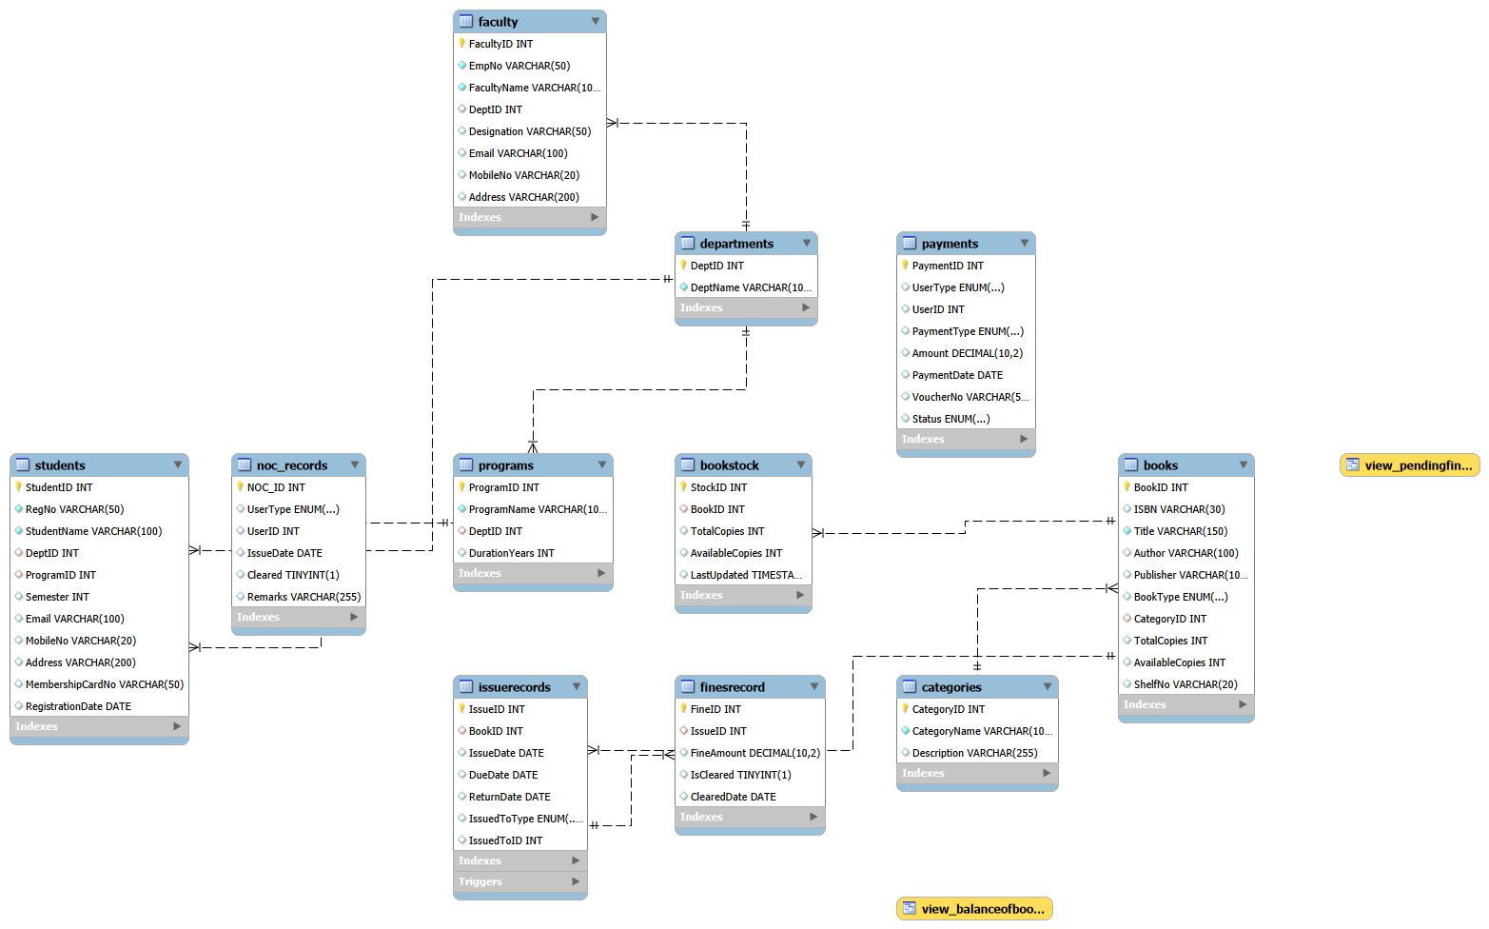
Diagram (ERD)

Step-by-Step MySQL Installation Guide:

- Download MySQL Installer:
Go to https://dev.mysql.com/downloads/installer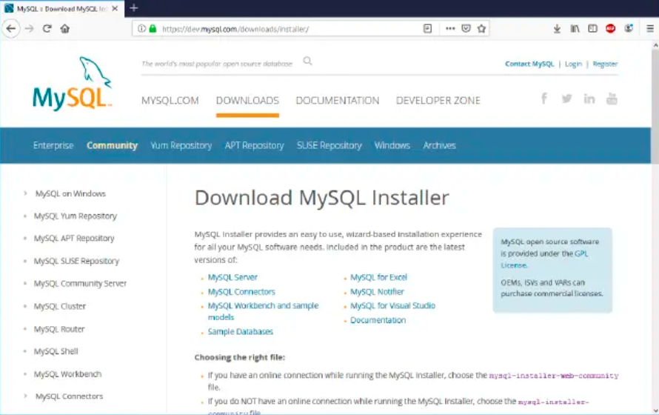

- Choose Setup Type:
Select Developer Default to install Workbench and MySQL Server.
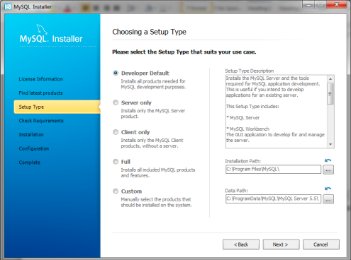

- Select Products and Features:
Confirm MySQL Server, Workbench, and Connector/J.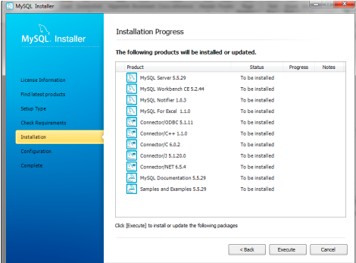

- Installation Process:
Click “Execute” to install all selected components.
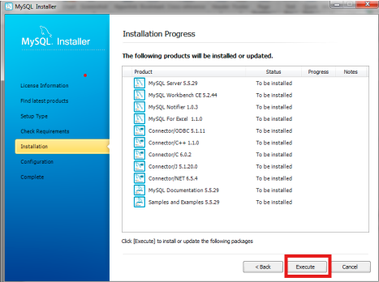

- MySQL Server Configuration:
  - Choose Standalone mode
  - Default port: 3306
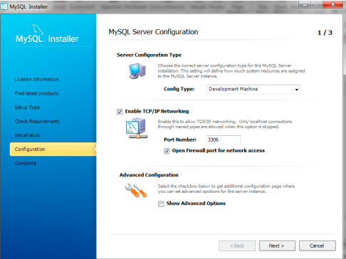

- Set Root Password:
Choose a secure password and remember it.
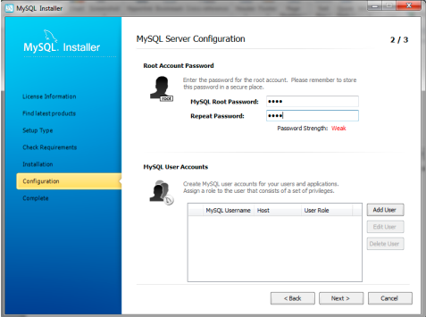

- Complete Installation:
Launch MySQL Workbench after installation.
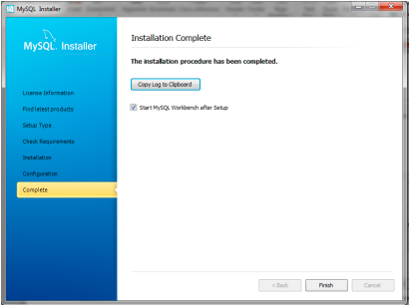

- Verify Installation:
Open Workbench → Create a new connection → Test Connection → Run a sample query.
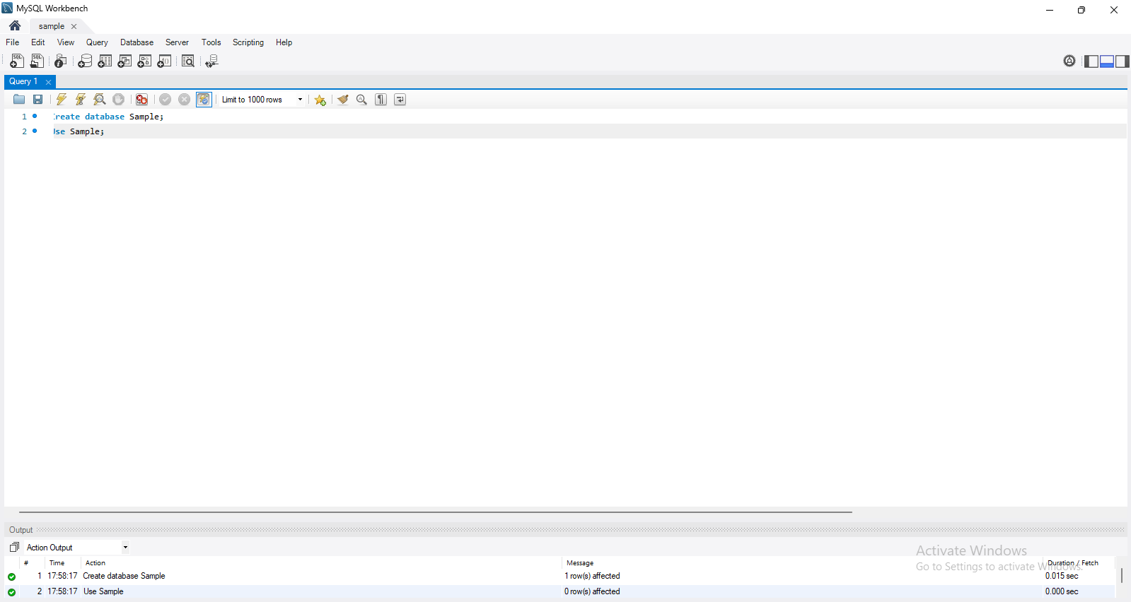

Step-by-Step Implementation

- Create Database

DROP DATABASE IF EXISTS Libraryauto_DB;
CREATE DATABASE Libraryauto_DB;
USE Libraryauto_DB;

Output:

Explanation:
Deletes any old version and creates a new library database.

- Create Roles

CREATE ROLE IF NOT EXISTS librarian;
CREATE ROLE IF NOT EXISTS student;
CREATE ROLE IF NOT EXISTS admin;

GRANT ALL PRIVILEGES ON Libraryauto_DB.* TO admin;
GRANT SELECT, INSERT, UPDATE, DELETE ON Libraryauto_DB.Books TO librarian;
GRANT SELECT, INSERT, UPDATE ON Libraryauto_DB.IssueRecords TO librarian;
GRANT SELECT ON Libraryauto_DB.Books TO student;

OUTPUT:
SHOW GRANTS;
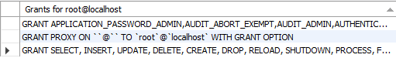

Explanation:
Creates roles for admin, librarian, and student and assigns privileges.

- Create Users and Assign Roles

CREATE USER 'sharjeel'@'localhost' IDENTIFIED BY '1234';
CREATE USER 'zarmeen'@'localhost' IDENTIFIED BY '1234';
CREATE USER 'abubakar'@'localhost' IDENTIFIED BY '1234';

GRANT librarian TO sharjeel@localhost;
GRANT student TO zarmeen@localhost;
GRANT admin TO abubakar@localhost;

SET DEFAULT ROLE librarian TO sharjeel@localhost;
SET DEFAULT ROLE student TO zarmeen@localhost;
SET DEFAULT ROLE admin TO abubakar@localhost;

OUTPUT:
SELECT user, host FROM mysql.user;
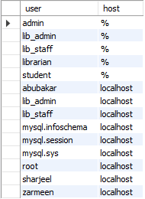
Explanation:
Creates user accounts and assigns appropriate roles.

- Revoke Some Privileges

REVOKE DELETE ON library_db.books FROM librarian;
REVOKE SELECT ON library_db.books FROM student;

Explanation:
Removes delete and select rights to enforce restricted access.

- Create Tables

CREATE TABLE Departments (
DeptID INT PRIMARY KEY AUTO_INCREMENT,
DeptName VARCHAR(100) UNIQUE NOT NULL
);

CREATE TABLE Programs (
ProgramID INT PRIMARY KEY AUTO_INCREMENT,
ProgramName VARCHAR(100) UNIQUE NOT NULL,
DeptID INT,
DurationYears INT DEFAULT 4,
FOREIGN KEY (DeptID) REFERENCES Departments(DeptID)
);

CREATE TABLE Students (
StudentID INT PRIMARY KEY AUTO_INCREMENT,
RegNo VARCHAR(50) UNIQUE NOT NULL,
StudentName VARCHAR(100) NOT NULL,
DeptID INT,
ProgramID INT,
Semester INT,
Email VARCHAR(100),
MobileNo VARCHAR(20),
Address VARCHAR(200),
MembershipCardNo VARCHAR(50) UNIQUE,
RegistrationDate DATE DEFAULT (CURRENT_DATE),
FOREIGN KEY (DeptID) REFERENCES Departments(DeptID),
FOREIGN KEY (ProgramID) REFERENCES Programs(ProgramID)
);

CREATE TABLE Faculty (
FacultyID INT PRIMARY KEY AUTO_INCREMENT,
EmpNo VARCHAR(50) UNIQUE NOT NULL,
FacultyName VARCHAR(100) NOT NULL,
DeptID INT,
Designation VARCHAR(50),
Email VARCHAR(100),
MobileNo VARCHAR(20),
Address VARCHAR(200),
FOREIGN KEY (DeptID) REFERENCES Departments(DeptID)
);

CREATE TABLE Categories (
CategoryID INT PRIMARY KEY AUTO_INCREMENT,
CategoryName VARCHAR(100) UNIQUE NOT NULL,
Description VARCHAR(255)
);

CREATE TABLE Books (
BookID INT PRIMARY KEY AUTO_INCREMENT,
ISBN VARCHAR(30) UNIQUE,
Title VARCHAR(150) NOT NULL,
Author VARCHAR(100),
Publisher VARCHAR(100),
BookType ENUM('Book','Journal','Thesis','Report','Newspaper','Magazine','Document') DEFAULT 'Book',
CategoryID INT,
TotalCopies INT DEFAULT 1,
AvailableCopies INT DEFAULT 1,
ShelfNo VARCHAR(20),
FOREIGN KEY (CategoryID) REFERENCES Categories(CategoryID)
);

CREATE TABLE IssueRecords (
IssueID INT PRIMARY KEY AUTO_INCREMENT,
BookID INT,
IssueDate DATE,
DueDate DATE,
ReturnDate DATE NULL,
IssuedToType ENUM('Student','Faculty'),
IssuedToID INT,
FOREIGN KEY (BookID) REFERENCES Books(BookID)
);

CREATE TABLE Payments (
PaymentID INT PRIMARY KEY AUTO_INCREMENT,
UserType ENUM('Student','Faculty'),
UserID INT,
PaymentType ENUM('Membership','Fine') DEFAULT 'Membership',
Amount DECIMAL(10,2),
PaymentDate DATE DEFAULT (CURRENT_DATE),
VoucherNo VARCHAR(50) UNIQUE,
Status ENUM('Paid','Pending') DEFAULT 'Paid'
);

CREATE TABLE FinesRecord (
FineID INT PRIMARY KEY AUTO_INCREMENT,
IssueID INT,
FineAmount DECIMAL(10,2) DEFAULT 0.00,
IsCleared BOOLEAN DEFAULT FALSE,
ClearedDate DATE NULL,
FOREIGN KEY (IssueID) REFERENCES IssueRecords(IssueID)
);

CREATE TABLE NOC_Records (
NOC_ID INT PRIMARY KEY AUTO_INCREMENT,
UserType ENUM('Student','Faculty'),
UserID INT,
IssueDate DATE DEFAULT (CURRENT_DATE),
Cleared BOOLEAN DEFAULT FALSE,
Remarks VARCHAR(255)
);

CREATE TABLE BookStock (
StockID INT PRIMARY KEY AUTO_INCREMENT,
BookID INT,
TotalCopies INT,
AvailableCopies INT,
LastUpdated TIMESTAMP DEFAULT CURRENT_TIMESTAMP ON UPDATE CURRENT_TIMESTAMP,
FOREIGN KEY (BookID) REFERENCES Books(BookID)
);

OUTPUT:
SHOW TABLES;
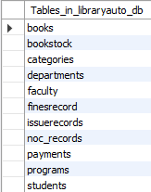
Explanation:
We now create all required tables with primary keys and relationships.

- Insert Sample Data

INSERT INTO Departments (DeptName) VALUES
('Computer Science'),
('Information Technology'),
('Artificial Intelligence');

INSERT INTO Programs (ProgramName, DeptID, DurationYears) VALUES
('BS Computer Science', 1, 4),
('BS Information Technology', 2, 4),
('BS Artificial Intelligence', 3, 4);

INSERT INTO Students (RegNo, StudentName, DeptID, ProgramID, Semester, Email, MobileNo, Address, MembershipCardNo) VALUES
('B2433073', 'Abu Bakar', 3, 3, 4, 'abu.ba@example.com', '0300-1111111', 'Lyari, Karachi', 'LIB-001'),
('B2433078', 'Awais Abdullah', 3, 3, 4, 'awais.chandio@example.com', '0301-2222222', 'Gulshan Iqbal, Karachi', 'LIB-002'),
('B2433113', 'Sharjeel Ahmed', 3,3, 4, 'Sharjeel.ahmed@example.com', '0302-3333333', 'Garden, West','LTB-003'),
('B2433136', 'Warda Nasir', 3,3, 4, 'warda.nasi@example.com', '0303-4444444', 'Shershah, Karachi','LTB-004'),
('B2433130', 'Zarmeen Moosa', 3,3, 4, 'zarmeen.m@example.com', '0304-5555555', 'Lyari, Karachi','LTB-005');

INSERT INTO Faculty (EmpNo, FacultyName, DeptID, Designation, Email, MobileNo, Address) VALUES
('EMP1001', 'Dr. Mazhar Dootio', 1, 'Professor', 'mazhar.d@example.com', '0312-1111112', 'Karachi'),
('EMP1002', 'Mr. Anwar Ali Sathio', 1, 'Lecturer', 'anwarsathio@example.com', '0311-1111111', 'Karachi'),
('EMP1003', 'Mr. Khuda Baksh', 3, 'Associate Professor', 'k.b@example.com', '0313-3333333', 'Karachi'),
('EMP1004', 'Ms. Nadia Murad', 2, 'Assistant Professor', 'nadia.m@example.com', '0314-4444444', 'Karachi'),
('EMP1005', 'Mr. Faisal', 1, 'Lecturer', 'faisal@example.com', '0315-5555555', 'Karachi');

INSERT INTO Categories (CategoryName, Description) VALUES
('Artificial Intelligence', 'AI and Machine Learning'),
('Database', 'Database Design and Management'),
('Programming', 'Coding and Best Practices'),
('Networking', 'Computer Networks'),
('Cyber Security', 'Security and Forensics');

INSERT INTO Books (ISBN, Title, Author, Publisher, BookType, CategoryID, TotalCopies, AvailableCopies, ShelfNo) VALUES
('978-1', 'Artificial Intelligence Basics', 'Dr. Imran Siddiqui', 'Oxford', 'Book', 1, 5, 5, 'A-1'),
('978-2', 'Machine Learning Journal', 'Dr. Sana', 'IEEE', 'Journal', 1, 2, 2, 'A-2'),
('978-3', 'Network Security Report 2024', 'Cyber Team', 'NCC', 'Report', 5, 1, 1, 'E-3'),
('978-4', 'University Newspaper', 'Media Dept', 'Campus Press', 'Newspaper', 4, 10, 10, 'N-1');

INSERT INTO IssueRecords (BookID, IssueDate, DueDate, IssuedToType, IssuedToID)
VALUES (1, '2025-10-01', '2025-10-10', 'Student', 1);

INSERT INTO Payments (UserType, UserID, PaymentType, Amount, VoucherNo, Status)
VALUES ('Student', 1, 'Membership', 500.00, 'VCH-001', 'Paid');

INSERT INTO BookStock (BookID, TotalCopies, AvailableCopies)
SELECT BookID, TotalCopies, AvailableCopies FROM Books;

OUTPUT:
SELECT * FROM Departments;
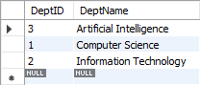
SELECT * FROM Programs;
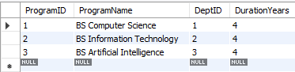
SELECT * FROM Students;
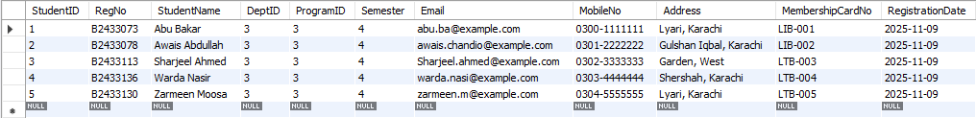
SELECT * FROM Faculty;
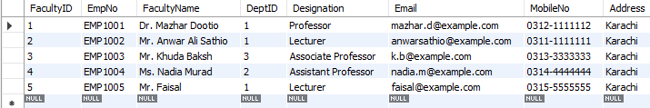
SELECT * FROM Categories;
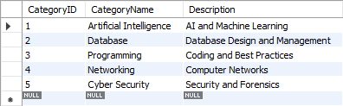
SELECT * FROM Books;
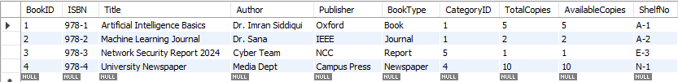
SELECT * FROM IssueRecords;
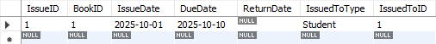
SELECT * FROM Payments;

Explanation:
We insert sample data in departments, students, faculty, categories, and books.

- Issue a Book

INSERT INTO IssueRecords (BookID, IssueDate, DueDate, IssuedToType, IssuedToID)
VALUES (1, '2025-10-01', '2025-10-10', 'Student', 1);

OUTPUT:
SELECT * FROM IssueRecords;
Explanation:
Student 1 issues Book ID 1.

- Create Trigger

DELIMITER $$

CREATE TRIGGER trg_book_return_update
AFTER UPDATE ON IssueRecords
FOR EACH ROW
BEGIN
IF NEW.ReturnDate IS NOT NULL THEN
UPDATE Books
SET AvailableCopies = AvailableCopies + 1
WHERE BookID = NEW.BookID;
END IF;
END$$

DELIMITER ;

OUTPUT:
SHOW TRIGGERS;
Explanation:
Whenever a book is returned, trigger updates available copies.

- Stored Procedures

DELIMITER $$

CREATE PROCEDURE CheckNoDues(IN userType ENUM('Student','Faculty'), IN userID INT)
BEGIN
DECLARE unpaidFines INT;
SELECT COUNT(*) INTO unpaidFines
FROM FinesRecord F
JOIN IssueRecords IR ON F.IssueID = IR.IssueID
WHERE F.IsCleared = FALSE
AND IR.IssuedToType = userType
AND IR.IssuedToID = userID;

IF unpaidFines > 0 THEN
SIGNAL SQLSTATE '45000'
SET MESSAGE_TEXT = 'Cannot issue book. User has pending dues/fines.';
END IF;
END$$

CREATE PROCEDURE GenerateVoucher(
IN userType ENUM('Student','Faculty'),
IN userID INT,
IN paymentType ENUM('Membership','Fine'),
IN amount DECIMAL(10,2)
)
BEGIN
INSERT INTO Payments(UserType, UserID, PaymentType, Amount, VoucherNo)
VALUES (userType, userID, paymentType, amount, CONCAT('VCH-', UUID()));
END$$

DELIMITER ;

Explanation:
Two stored procedures automate dues checking and fine voucher creation.

- Views

CREATE OR REPLACE VIEW View_BalanceOfBooks AS
SELECT B.BookID, B.Title, B.BookType, B.TotalCopies, B.AvailableCopies,
(B.TotalCopies - B.AvailableCopies) AS IssuedCopies
FROM Books B;

CREATE OR REPLACE VIEW View_PendingFines AS
SELECT
F.FineID,
B.Title,
CASE
WHEN IR.IssuedToType='Student' THEN S.StudentName
ELSE T.FacultyName
END AS Borrower,
F.FineAmount,
F.IsCleared
FROM FinesRecord F
JOIN IssueRecords IR ON F.IssueID = IR.IssueID
JOIN Books B ON IR.BookID = B.BookID
LEFT JOIN Students S ON IR.IssuedToType='Student' AND IR.IssuedToID=S.StudentID
LEFT JOIN Faculty T ON IR.IssuedToType='Faculty' AND IR.IssuedToID=T.FacultyID;

OUTPUT:
SELECT * FROM View_BalanceOfBooks;
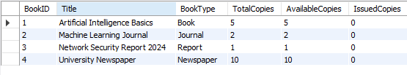
SELECT * FROM View_PendingFines;
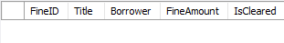
Explanation:
Views summarize issued books and pending fines.

Conclusion
This lab successfully implemented a complete Library Automation System using MySQL.
It covers:
- 3NF-based relational design
- Use of roles, users, privileges
- Tables with constraints and foreign keys
- Triggers, stored procedures, and views for automation
- Realistic data management simulation

Result:
An efficient and secure Library Database that automates book management, fine calculation, and user access.

Question/Answers

Q) How do you ensure maintenance and scalability? (Mudabbir Wassay)
Answer:
The system ensures maintenance and scalability through the use of normalized database design, foreign key relationships, and modular entities (Departments, Programs, Books, Students, etc.). This structure allows easy updates and extensions without affecting other tables.
Additionally, stored procedures, triggers, and views centralize logic, reducing code duplication and simplifying maintenance. New tables or relationships can be added without redesigning the entire database.

Q) What are the core entities or sub-entities in your system? (Sumaira Farhan)
Answer:
Core entities and sub-entities include:
- Departments → contains department information.
- Programs → linked to departments.
- Students and Faculty → represent users who borrow books.
- Categories and Books → represent the library’s collection.
- IssueRecords, Payments, FinesRecord, NOC_Records, and BookStock → represent library transactions and operations.
These are connected using foreign keys, forming a relational structure.

Q) Is your database secure from SQL Injection and other cyber attacks? If yes, how? (Sumaira Farhan)
Answer:
Yes. Since we used MySQL roles and privileges instead of direct query access, each user has restricted permissions.
For example:
- Students have only SELECT access (read-only).
- Librarians can SELECT, INSERT, and UPDATE but not DELETE.
- Admins have full access.
This principle of least privilege prevents unauthorized modifications.
Also, since there is no GUI and queries are predefined, the chance of SQL injection is minimal.

Q) Who has been given access, and what type of access do they have? (Mateen, Anus Kamboh)
Answer:
User | Role | Privileges Granted
Abu Bakar | Admin | ALL privileges on the database.
Sharjeel | Librarian | SELECT, INSERT, UPDATE on Books & IssueRecords (no DELETE).
Zarmeen | Student | SELECT access (view-only).
Access is role-based, managed through MySQL roles and GRANT statements.

Q) What security implementations are present in your system? (Hassan Niazi)
Answer:
- Role-based access control (RBAC): Ensures each user can only perform allowed actions.
- Triggers: Automatically handle updates (e.g., return book updates availability).
- Procedures: Encapsulate logic to avoid manual query manipulation.
- No GUI: Reduces exposure to injection and phishing attacks.

Q) What is the use of a delimiter? (Hassan Niazi)
Answer:
A delimiter in MySQL defines the end of a command.
Since stored procedures and triggers contain multiple SQL statements separated by semicolons, we change the delimiter temporarily (e.g., DELIMITER $$) so MySQL knows where the procedure ends.
After defining, it is set back to the default ;.

Q) Can a table have more than one attribute? (Mohsin Shah)
Answer:
Yes. Each table can have multiple attributes (columns).
For example, the Books table has several attributes such as BookID, Title, Author, Publisher, BookType, CategoryID, TotalCopies, and others.
Each attribute stores a specific piece of data about that entity.

Q) What security measures are you taking to ensure reliability and protection, especially since you don’t have a GUI for enhanced security yet? (Bonita Naqvi)
Answer:
- Access control through roles and privileges (admin, librarian, student).
- Encrypted password authentication at the MySQL level.
- Restricted access to specific tables per user type.
- Triggers and constraints to prevent inconsistent data.
- No direct user input (no GUI) means fewer attack vectors.
- Data validation inside stored procedures ensures safe transactions.

Q) Are you using JOINs? If yes, where and why? (Bonita Naqvi)
Answer:
Yes. JOINs are used in views and stored procedures to combine related data from multiple tables.
For example:
- In the view View_PendingFines, I used JOINs between FinesRecord, IssueRecords, Books, Students, and Faculty to show fines with borrower details and book titles.
JOINs are essential to retrieve combined, meaningful information instead of separate records.

------------------------------------END-------------------------------------

